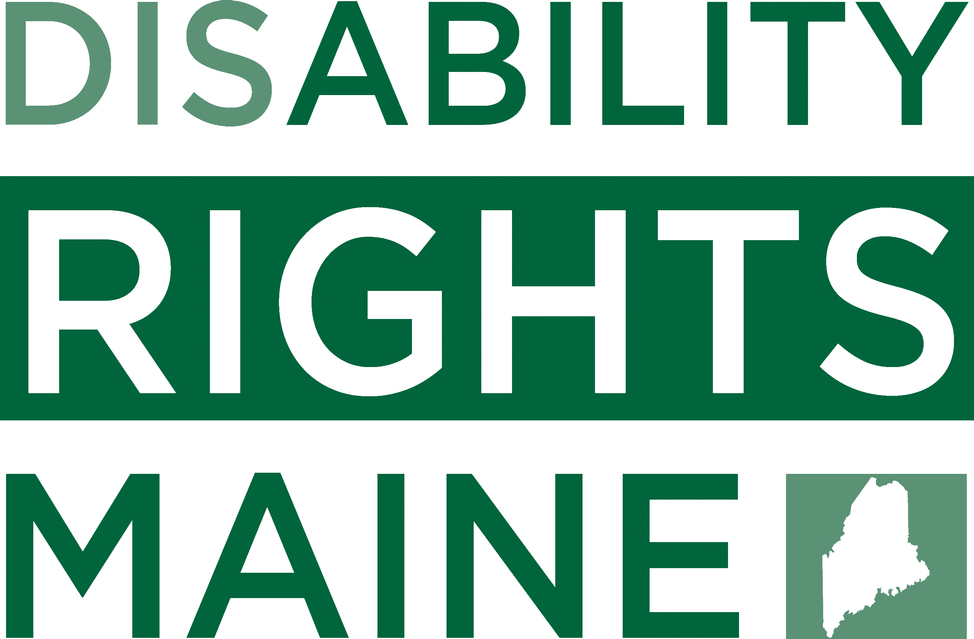

Maine Voters with Disabilities:
We want to hear your stories!

Voters with disabilities have the right to vote independently and privately, just like all other citizens. Disability Rights Maine wants to hear your stories about problems you might have had when voting or trying to vote in the recent election. Some common problems include:

- Accessing polling facilities (i.e. parking spaces, ramps, doorways)
- Getting assistance with voting at the polls or town offices
- Completing forms for registration, absentee ballots

If you have experienced any issues related to being a voter with a disability during the recent election, Disability Rights Maine would like to talk to you now. To tell us your story, please contact us at 1-800-452-1948 or via email at rlangley@drme.org.
PROTECTION & ADVOCACY for VOTING ACCESS
www.drme.org

