Survivors & Guardianship in Maine
A Guide for Sexual Assault Advocates
Individuals with Intellectual Disabilities, Autism, and other developmental disabilities are at far greater risk of experiencing sexual violence than the general population. As many as 83% of females and 32% of males with DD experience sexual assault. In Maine, about 68% of adults with DD who receive support services are under some form of guardianship (more than twice the national average). This Guide is intended to provide information to assist sexual assault advocates in effectively supporting survivors with DD, and in navigating questions that may arise when individuals have a legal guardian.

What is Guardianship?
Guardianship is the result of a formal judicial process (in Probate Court) that gives an individual’s decision-making authority to someone else. Guardianship is always established by court order; there is no such thing as an “informal” guardianship. It is the most restrictive arrangement, and is reserved only in circumstances where a court has found that a person is unable to receive or evaluate information to make decisions, and that no less restrictive alternative is appropriate. That said, many guardianships in Maine were put into place unchallenged by the person and without robust scrutiny as to whether they are necessary. Guardianships can be public (DHHS is guardian) or private (anyone not DHHS, usually a family member), and can be full or limited. Full guardianship has been described as “civil death” by disability rights advocates because an individual under guardianship is stripped of legal capacity and fundamental civil rights, such as the ability to make choices about housing, healthcare, and finances.

Can a Guardian Prevent an Individual’s Access to Sexual Assault Services?
In short, no. A guardian is a “fiduciary” of the adult subject to guardianship, which means they are required to make decisions in the person’s best interest. In addition, guardians do not have authority to place restrictions on contact of the adult under guardianship, except in narrow circumstances where there is a court order, or the guardian believes the contact poses a danger to the person. Most importantly, a law enacted in 2021 says that a person under guardianship retains the right to work with an attorney or an advocate of their choosing, free from guardian interference.

Supporting Survivors Who Are Subject to Guardianship
Sexual assault advocates can work privately with survivors who are subject to guardianship in the same way they can work with survivors who are not subject to guardianship. Advocates should speak directly with the person to determine what, if any, role they would like the guardian to play. It is best to keep in mind that many individuals with developmental disabilities are taught to be compliant, and advocates should be mindful of that to best determine whether an individual is stating their own preference, or stating what they believe the questioner wants to hear. Individuals with developmental disabilities are also likely have a case manager. Ask the individual if their case manager would be a good ally.

What Can Be Done If You Suspect a Violation of Rights?
- In collaboration with the survivor (as we do with all mandated reporting), call APS to make a report. This will likely trigger an investigation.
- Call Disability Rights Maine at (207) 626-2774 with the client to speak to a Developmental Services Advocate.
- Not sure a rights violation has occurred? Call DRM with de-identified information to get general information.

About Disability Rights Maine
Disability Rights Maine (DRM) is Maine’s Protection & Advocacy agency for people with disabilities. DRM represents people whose rights have been violated or who have been discriminated against based on their disability. They also provide training on rights and self-advocacy, and advocate for public policy reform.

The Developmental Services Advocacy (DSA) program at DRM provides legally based advocacy services to adults with intellectual disabilities and autism. The DSA program is contracted to receive reports made to DHHS that relate to issues around violations of rights. DRM conducts trainings of the rights of people with DD, where you can learn more about the rights of people with disabilities. DRM also trains statewide on alternatives to guardianship, such as Supported Decision-Making.

Additional Resources
Crisis Services - Office of Aging & Disability Services, Maine DHHS
1-888-568-1112 (ask for a “DS Crisis Worker”)
The Developmental Services (DS) crisis system is for anyone with developmental disability or brain injury. DS Crisis provides assistance to individuals, families, guardians, and providers to maximize individuals’ opportunities to remain in their homes and local communities during and after crisis incidents.

Adult Protective Services - Office of Aging & Disability Services, Maine DHHS
To report abuse, neglect or exploitation, call 24-hour, toll-free 1-800-624-8404
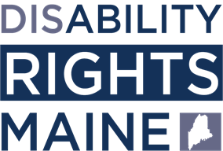
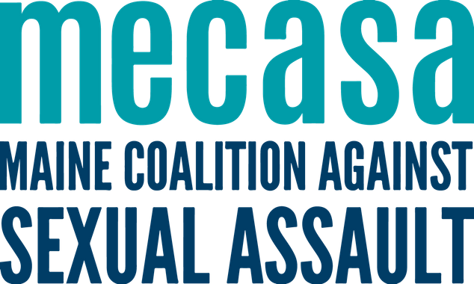
Adult Protective Services (APS) investigates reports of abuse, neglect, and exploitation of dependent adults.
d
r
m
e
.
o
r
g
m
e
c
a
s
a
.
o
r
g

