How to Register for
Emergency Alerts

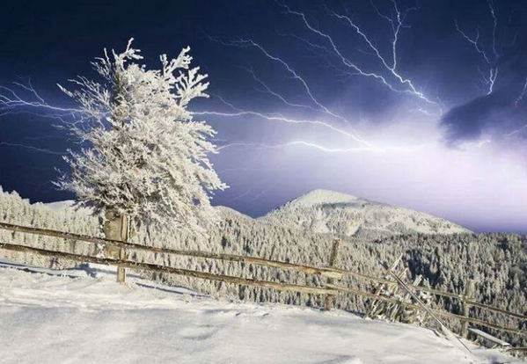

- Register for “Citizen Alerts” at: ww.maine.gov/portal/CAS/

mber/Kidnapping Alerts | omeland Security Alerts
ealth Epidemics or Threats to Public Health
evere Weather Warnings | tate Government Office Closings

Carefully pick which alerts you want so you don’t get too many!

Or follow @maine.gov_news on Twitter for quick updates

- The Maine Emergency Management Agency (MEMA)
also provides weather updates and other news.
Register at: www.maine.gov/mema/mema_subscribe.shtml

- Get travel alerts from the Maine Turnpike Authority:
Register at: www.maineturnpike.com/Traveler-Services/Travel-Alert-Sign-up.aspx

