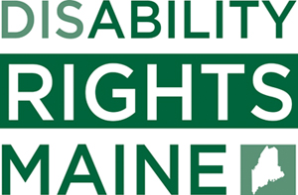
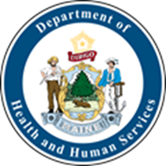
COVID-19: PERSON-CENTERED DISCUSSION TOOL FOR ASSESSING THE RISKS OF HAVING VISITORS AND ACCESSING THE COMMUNITY

FROM: DHHS OFFICE OF AGING AND DISABILITY SERVICES, DISABILITY RIGHTS MAINE, AND SPEAKING UP FOR US

COVID-19 is challenging for all and has made a lot of things change for people with disabilities. Now that we have entered a new phase of this emergency with many businesses, parks, restaurants, etc. reopening, OADS, DRM, and SUFU are receiving questions about rights and restrictions from both providers of services and individuals served.

Given that the rights of individuals with disabilities and the responsibility of providers to ensure health and safety may at times conflict with each other, OADS, DRM, and SUFU offer the following Risk/Benefit Discussion Guide to help individuals make the best decisions for themselves with the support of their families, case managers, and others. This tool* is an optional way to think about some of the health and safety risks that a person should consider before taking part in a new community activity and/or interacting with new individuals. As always, Person-centered principles should guide everyday practice before, during, and after an emergency.

Decision-Making Considerations for Individuals with Developmental and Intellectual Disability, Autism, and Brain Injury Regarding Access to their Communities as the State of Maine Starts to Re-Open.

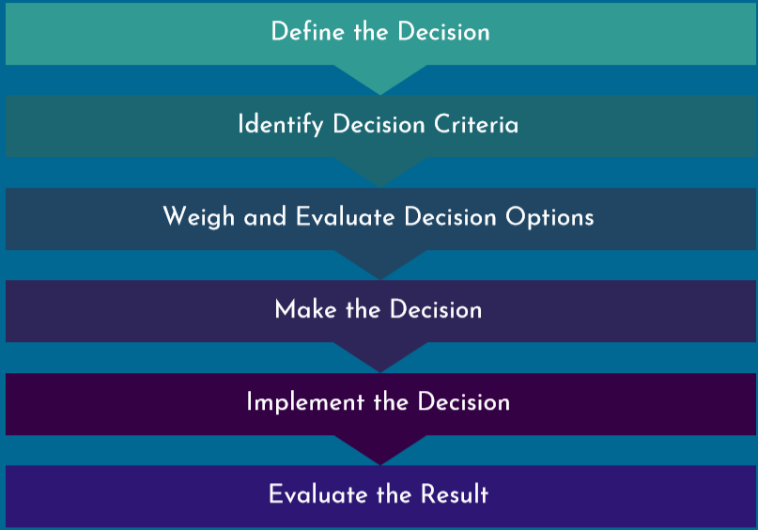
Decision making includes a process of selecting the best choice among many different options. Every person makes many decisions every day, and the decisions range from simple ones, such as what to eat to more complicated and important decisions, such as ones that we face now related to COVID-19. This basic decision-making guidance is based on the rational decision-making model. This model includes some steps to help people make the best decision given their goals and possible barriers.

Model above based on a Rational Decision-Making Process

- Define the Decision: What Do I Want to Do?

  - Some key questions about where I want to go/how I want to visit with someone:
    - Will I be inside or outside?
    - How many other people will be there?
    - Can I and will the other people around me follow safe distancing guidelines?
    - How long will I be away from the home (hours versus days)?
    - Can I get a face face-covering? Will others be wearing face-coverings?

- Identify Decision Criteria: What Should I Think About as I Make My Decision?

  - Am I currently able to or can someone remind me to stay at least 6 feet apart from others?
  - Am I currently able to wear a face covering for the period that is necessary for a specific outing by myself or with assistance?
  - Do I need support normally when accessing the community and is that support needed for the activity? If so, is that support available now?
  - Will I need to quarantine after the activity because of the Governor’s order? Is it possible for me to quarantine?
  - What are the potential benefits to me?
    - Will it improve my physical and/or mental health?
    - Will it reduce my anxiety or stress?
    - Will it help maintain important relationships and/or community connections?
    - Will I be able to earn income, etc.?
    - Will it be fun and a nice change for me?
  - Do I have additional COVID health risks, such as?
    - Diabetes
    - Older than 60
    - Having lung or breathing issues
    - Having heart issues, including high blood pressure
    - Other medical issues such as HIV, cancer, post-transplant, etc.
    - Having kidney disease
    - Having other underlying health problems
  - Do I live with anyone with additional COVID health risks, such as those listed above?
  - If I live with others, have we talked about how we feel about others in the home accessing the community and having visitors?

- Weigh Decision Options: What Else Should I Consider and Whose Opinion should I Consider as I Think About Decision Options?

  - Do other members of my team agree with my responses to the questions above?
  - Do other members of the team (such as my guardian, if applicable, and my staff) agree with my choice?
  - If there are concerns about my choice, can my team help me identify alternatives that I could agree to? Remember, your agreement must be voluntary. This means that no one can make you agree to a different choice and you can change your mind about your choice at any time.
  - Am I prepared to accept the possible outcomes of my choice, such as having to quarantine upon my return?

- Make My Decision

  - If your agency disagrees with your choice and determines that implementing this choice would create an emergency, in some circumstances they may prevent you from doing so. They may only do this if this is an emergency.
    - An emergency means there is a situation in which there is imminent risk of harm or danger to the person or community.
    - If your provider believes there is an emergency and restricts your right to access the community or have visitors, the agency (and your case manager, if applicable) must file a Reportable Event - and tag it to advocacy.
    - When Disability Rights Maine receives the reportable event, they will review the situation and determine how they might be able to help. Before they do anything, DRM will make contact with you to talk about how you want to be helped. DRM’s help could include advocating for your initial choice or working with you and your team to find an agreed-upon alternative.

- Implement the Decision and Evaluate the Result: Planning for Next Time

  - After the decision is made and implemented, it is helpful to talk about it with your team to decide if you liked the decision you made, or if you want to change your mind to make a different decision.

Frequently Asked Questions Regarding Provider Restrictions on Visitors and Addressing Situations to Ensure Waiver Members Access their Communities Safely:

Question: If I believe my support team (provider, case manager, etc.) are not listening to my concerns or requests about going into the community what can I do?

Answer: You can remind your provider agencies that they work for you and then ask to have a meeting to discuss your concerns. If you think it would help, you can invite someone from Disability Rights Maine to attend this meeting with you.

Question: Can a waiver provider evict an individual or refuse to let him or her back into the home, if the provider believes that the individual has accessed the community in an unsafe way?

Answer: No, This is a rights violation. A provider cannot legally prevent someone from returning to their home or evict them without following normal, safe discharge procedures and the eviction process.

Question: What should an agency do when a family refuses to follow the guidelines of how to visit their family member in group home settings at this time?

Answer: The family members should be encouraged to interact remotely using virtual technology or safely visit following these visiting guidelines. Case managers and providers should help educate family members about precautions.

Question: When an individual who lives in a group home attends a medical appointment, or goes shopping following CDC guidelines, does he or she need to quarantine at home after this?

Answer: If the individual follows the CDC guidelines, including social distancing and wearing a face covering, then the individual should not need to quarantine when they return, unless they have been directed to do so by their family care provider or other medical professional.

Question: What is the type of face covering that is required by individuals when they are accessing their communities?

Answer: The Governor has updated an Executive Order on July 8, 2020 which reemphasizes the need for people to wear face coverings, which “shall be construed to include disposable face coverings of similar quality as well as face shields, provided that such face shield extends below the chin and covers the ears”.

Question: What do I tell a family member or guardian if they say they want to take an individual who lives in a group home on a week-long vacation?

Answer: Using the above decision-making outline, work with the individual and their team. If agreement cannot be reached, support the person to contact DRM if they would like assistance.

If you need assistance understanding or advocating for your rights, call Disability Rights Maine at 800.452.1948, or use our online intake form https://drme.org/online-intake-form.

