YOUTH AND FAMILY INPUT NEEDED!

Maine’s Office of Child and Family Services is conducting an independent assessment of Children’s Behavioral Health Services

- Maine has hired Public Consulting Group (PCG) to conduct the assessment.
- The assessment will look to identify strengths, weaknesses, and gaps in Maine’s existing service options for children and families. This includes, but is not limited to: home and community services; crisis services; emergency services; hospital-based services; residential services; and respite.
- The assessment will include gathering information and researching best practices nationwide to develop solutions that address identified problem areas.
- Short and long term recommendations will be provided to address problems within the system.
PCG is conducting a web-based survey to get direct input from youth and families regarding Children’s Behavioral Health Services within the next few weeks. Several “Town Hall” meetings will also be held throughout Maine so that PCG can provide information about their work and gather more information from stakeholders. DRM will post these dates on its website and social media platforms when dates are confirmed.
You can also email PCG directly with your thoughts or ideas, including recommendations, on how to make the system better: Susan Foosness, Project Manager sfoosness@pcgus.com.

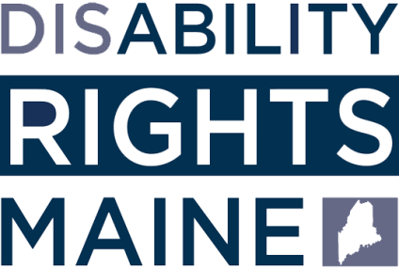

160 Capitol Street, Suite 4
Augusta, Maine 04330

