Kozala Ebosono Rights Maine
Bolukiluki mpo na Bolengeli Kolongono ya Nzoto
Toza na mposa toyoka yo!
Balotomo ya Bibosono ya Maine (DRM) ezoyamba bansango oyo ezotalisa bibosono oyo baza na mikakatano mpo na bolengeli kolongono ya nzoto. Sikawa, bansango yango ezali te! Bolukiluki ekosalema na nkuku mpe ekoyebana te.
Bakosalela bansango oyo mpo na kolobela likambo litali mbongwana. Mpo na kosala yango, toza na mposa ya lisungi na yo!
Ndenge nini nakoki kopesa eyano na bolukiluki?
- Na internet, na telefone, na ordinatere to na tablette
- likolo lolenge ya papye
- Elongo na lisalisi lya libota, lya ndeko to mosali wa DRM (oyo aza na telefone, na Zoom to aza kosala ye moko)
Esika nini nakoki kozwa bolukiluki na internet?
Salela ekanganeli to ozwi code QR mpo na kokota na bolukiluki.
Bolukiluki | Bolukiluki mpo na Elobeli ya Bajeste ya bato ya Amerika
https://survey.alchemer.com/s3/7084454/DRMsurvey2022 |  | https://survey.alchemer.com/s3/7090703/ASLDRMsurvey2022
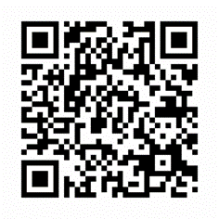
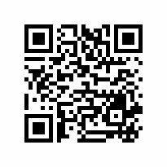
Bolukiluki ekoki kosalema na monoko nyonso na nzela ya esalelo babengi LanguageLine. Esengeli obenga Jennifer Battis mpo na boyokana na ntango esengeli mpo na opesa biyano na bolukiluki na monoko na yo.
Mpo na basango mususu esengeli kobenga: Jennifer Battis
jbattis@drme.org
(207) 626-2774

