Naafada Xuquuqda Maine
Sahan Kusaabsan Helitaanka Daryeelka Caafimaadka
Waxaan u baahanahay inaan kaa maqalno adiga!
Disability Rights Maine (Xuquuqda Naafada Maine, DRM) waxa ay ururinayaan xogta kusaabsan arrimaha dadka naafada ah ay la kulmaan marka ay helayaan daryeelka caafimaadka. Waqti xaadirkan, xogtani ma ahan mid jirto! Xog ururintani waa mid sir ah oo qarsoon.
Macluumaadka waxaa loo isticmaali doonaa in loogu doodo in la sameeyo isbeddel.
Si tani loo sameeyo, waxaan ubaahanahay inaad naga caawiso!

Sidee ayaan u sameynayaa sahanka?
- Onlayn, adigoo isticmaalaya taleefankaaga, kumbiyuutarkaaga, ama taabledkaaga
- Qaab warqad ah
- Adigoo caawin kahelaya qoyska, asxaabta, ama shaqaalaha DRM (waxaa lagu heli karaa taleefan, aaladda Zoom-ka, ama si fool-ka-fool ah)
Halkee ayaan kaheli karaa sahanka onlaynka ah?
Isticmaal liinkiga ama iskaangaree QR koodhka si aad u gasho sahanka.
Sahanka | Sahanka Luqadda Calaamadaha Dhagoolaha ee Maraykanka
https://survey.alchemer.com/s3/7084454/DRMsurvey2022 |  | https://survey.alchemer.com/s3/7090703/ASLDRMsurvey2022
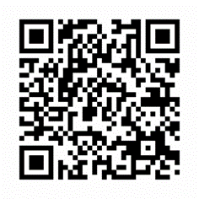
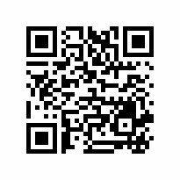
Sahanka waxaa lagu sameyn karaa luuqad kasta iyadoo la adeegsanayo LanguageLine. Fadlan la xiriir Jennifer Battis si aad u qabsato waqti aad luuqadaada ku sameyso sahanka.
Wixi macluumaad dheeraad ah kala xiriir: Jennifer Battis
jbattis@drme.org; (207) 626-2774

