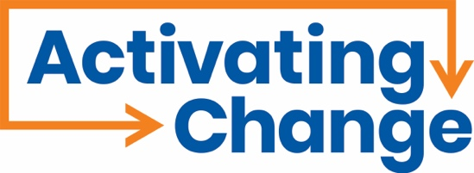

Activating Change, in partnership with the Office for Victims of Crime, Office of Justice Programs, is working on a project that will develop resources and best practices for victims of abuse at the hands of a direct support professional or personal care attendant. A vital component of this work is learning directly from the people with the most experience with personal care attendants. By participating in our listening session, you will critically assist Activating Change in reaching our four project goals:

1. To identify current response practices and gaps in service response for victims of crimes committed by paid personal care attendants.
2. To develop promising practices for serving victims of crimes committed by paid personal care attendants.
3. To assess and refine promising practices.
4. To promote the wide-spread adoption of the promising practices developed.

The only criteria to participate in the listening session is that you are an individual with a disability who uses a personal care attendant for activities of daily living.

DATE: October 31, 2024
TIME: 11:00am ET/10:00am CT
WHERE: Virtually on Zoom

Please RSVP to Jannette Brickman at jbrickman@activatingchange.org. We welcome accommodation requests that will assist you in fully participating in our listening session. When RSVPing, please let Jannette inform her of your accommodation requests or to inform about any modifications or needs you have during the listening session. Your comfort is our top priority.

We look forward to learning from you!

This document was produced by Activating Change under award #15POVC-23-GK- 02768-NONF, awarded by the Office for Victims of Crime, Office of Justice Programs, U.S. Department of Justice. The opinions, findings, and conclusions or recommendations expressed in this document are those of the contributors and do not necessarily represent the official position or policies of the U.S. Department of Justice.

