**NI IKI TWAMENYA KU GUTORA KUDAHEZA MURI MAINE**

 Itegeko ryo ku rwego rw’igihugu ndetse ni ryo ku rwego rwa leta riteganya ko inzira yo gutora yose igomba kuba idaheza kuri bose.

 Aho gutorera hose hagomba kuba hadaheza.

 Abatora bafite uburenganzira bwo kugira umuntu ubafasha kuzuza impapuro z’itora.

 Niba ushaka gutora wenyne ntawe uguhagaze hejuru, Ushobora gukoresha uburyo bwo gutora budaheza bwa Maine.

 Maine itanga uburyo bwo gutora bwitwa

"Electronic Accessible Absentee Voting" buhabwa abantu bafite ubumuga bafite cyangwa bashobora kugira imbogamizi zo kuzuza impapuro z’itora.

**UBUNDI BUVUZE IKI UBURYO BWO GUTORA BUDAHEZA BWA MAINE ?**

 Maine ifata itora nk’irigomba kuba ridaheza rizwi ku izina rya Accessible voting System (AVS).

Ahantu hose habera itora hifashishijwe itegeko ry’Amerika ry’amatora Help America Vote Act (HAVA) hagomba kuboneka ku munsi w’itora uburyo budaheza abafite ubumuga. The ExpressVote:

* Ni imashini ifasha abantu bafite ubumuga gutora mu bwigenge ntawe ubahagaze hejuru;
* Utora ahitamo gutora akoresheje gukora mu kirahure k’imashini bizwi nka touchscreen

cyangwa taburo ifite amatushe ifite ndetse

n’amajwi;

* Usohora urupapuro wujuje mu mashini;
* Ntiba iri kuri interineti.

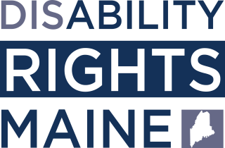

**NI UBUHE BURYO BWO GUTORA BUDAHEZA BUKORESHA IMASHINI?**

 Niba ushaka gutora ukoresheje imashini kandi ufite ubumuga bukugora gutorera ku

mpapuro, ushobora gusaba imashini idaheza.

 Ukeneye ubu buryo bw’itora budaheza, abusaba nibura amaezi atatu mbere y’igihe k’itora.

 Gutora ukoresheje ubu buryo budaheza ugomba kuba ufite interineti ndetse n’iyi mashini.

 Ukimara gusaba iyi mashini, uzohererezwa muri email amabwiriza yo kuyitoresha.

**UBUNDI BUFASHA**

 Kwiga iby’ubu buryo bw’itora budaheza bwa Maine, sikana cyangwa scan the QR code.

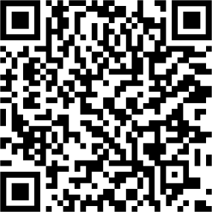

**Questions?** Soma hano: https://drme.org/voting

**Email:** [advocate@drme.org](mailto:advocate@drme.org)

**Call:** 207.626.2774 (V/TTY); 800.452.1948 (V/TTY);

207.766.7111 (VP)