|  |  |
| --- | --- |
| THE 2024 ELECTION REPORT: VOTING ACCESS FOR MAINERS WITH DISABILITIES |  |
|  |  |



# Language disclaimer: Language is a powerful tool that shapes meaning and understanding. This report uses person-first and identity-first language interchangeably to reflect the diverse ways the disability community identifies. Person-first language places the person before their disability. Identity-first language embraces disability as a fundamental aspect of one's identity and places identity first. For more information about combating ableism through language, we recommend the following:

[National Disability Rights Network: Communicating About People with Disabilities](https://www.ndrn.org/resource/communicating-about-people-with-disabilities/)

[National Center on Disability and Journalism: Disability Language Style Guide](https://ncdj.org/style-guide/)

[Autistic Self-Advocacy Network: Identity-First Language](https://autisticadvocacy.org/about-asan/identity-first-language/)

# TABLE OF CONTENTS

TABLE OF CONTENTS 3

APPRECIATION 4

EXECUTIVE SUMMARY 5

EDUCATION AND OUTREACH 6

EXPANDING LANGUAGE ACCESS 7

ACCESSIBLE ELECTRONIC ABSENTEE BALLOT 7

SPECIAL CIRCUMSTANCES VOTING INFORMATION 7

ELECTION DAY 2024 8

POLLING PLACE MONITORING: GENERAL OBSERVATIONS 9

RESULTS AT A GLANCE: ADA COMPLIANCE 10

RESULTS AT A GLANCE: HAVA COMPLIANCE 11

ADA COMPLIANCE 12

ADA COMPLIANCE DATA 13

HAVA COMPLIANCE 29

HAVA COMPLIANCE DATA 30

APPENDIX 35

2024 VOTER EDUCATION: PROGRAM RECIPIENTS 38

POLLING PLACE ACCESSIBILITY SURVEY 39

POLLING PLACES VISITED 42

# APPRECIATION

DRM wishes to thank the following organizations and individuals for their collaboration in expanding the disability vote in Maine:

* American Association of People with Disabilities
* Consumer Council System of Maine
* Democracy Maine
* Equality Maine
* Maine League of Women Voters, Election Observation Volunteers
* Maine Town and City Clerks Association
* National Disability Rights Network
* Office of the Secretary of State, Elections Division
* Secretary of State, Shenna Bellows
* Speaking Up For Us

# EXECUTIVE SUMMARY

In 2024, Disability Rights Maine (DRM) undertook significant efforts to increase the disability vote in Maine via the federal *Protection and Advocacy for Voting Access (PAVA) Program*. PAVA was signed into law via the Help America Vote Act (HAVA). The aim of the program is to increase the disability voter turnout and train election officials on election accessibility.

DRM engaged with hospitals, community support programs, and schools, to ensure eligible individuals received education on their voting rights. As a result, hundreds of individuals with disabilities were trained in the voting process and the importance of civic engagement.

Beyond training individuals with disabilities, DRM trained over 600 election officials in Maine on compliance with the Americans with Disabilities Act (ADA) and HAVA. DRM partnered with the Secretary of State to offer two remedial training courses in March of 2024 for election officials whose polling places were not in compliance with the law in the preceding Referendum Election. In September of 2024, DRM presented two, one-hour training courses to municipal election officials on polling place accessibility in advance of the General Election. Finally, DRM presented a 30-minute training to all 200 poll workers in the City of Portland, on temporary solutions to ensure accessibility at polling places and the importance of the Accessible Voting System.

On Election Day 2024, DRM staff visited polling places in all 16 Maine counties to check for compliance with the ADA and HAVA. DRM collected over 8,000 data points from 210 polling places. The findings indicate that minor structural barriers (probable ADA violations) are widespread across Maine’s polling places. 171 out of 210 polling places were not entirely in ADA compliance, although they could still largely be accessed by people with disabilities. The problems observed can be easily remedied by municipalities at little cost, by displaying proper signage for accessible parking and accessible entrances. Compared to DRM’s 2023 assessments of polling places, serious violations such as no accessible entrances and no accessible parking, that would deny people with disabilities access to a facility, were rare.

# EDUCATION AND OUTREACH

In the year leading up to the November 5th, 2024, General Election, DRM’s Voting Access Program conducted trainings across the state targeting election officials and people with disabilities. 1,129 individuals were trained on varying topics from voting rights, to accessible polling places, and accessible voting options.

# Town and City Clerks

In conjunction with the Elections Division from the Secretary of State’s Office, DRM trained 452 municipal election officials on complying with the ADA and HAVA. At these trainings, DRM instructed officials on how to ensure accessible polling places, the best practices of interacting with voters with disabilities, and the importance of the Accessible Voting System.

# City of Portland Election Officials

DRM presented at four election worker training sessions for the City of Portland. Election officials were instructed on how to ensure polling place accessibility, set up the Accessible Voting System, and respectfully interact with voters who communicate in non-traditional means. In February 2024, 18 polling place wardens and clerks received this training. In October 2024, over 200 poll workers in the City of Portland received this training.

# Office of Aging and Disability Services (OADS)

OADS invited DRM to present at a monthly training series for direct support professionals (DSPs). The topic of the series was “Community and Civic Engagement.” DRM presented to 38 DSPs regarding the best practices for assisting clients in the voting process.

# Individual Trainings

DRM’s Voting Access Advocate traveled around the state to meet with disabled people and educate individuals on the voting process. The purpose of the training was to empower individuals to exercise their civil rights. The Voting Access Advocate specially trained 591 people with disabilities in the months leading up to the General Election. The Advocate trained individuals on the voting process, voter registration requirements, and accessible voting options.

# EXPANDING LANGUAGE ACCESS

DRM received a grant from the American Association of People with Disabilities (AAPD) to translate existing materials to accommodate clients and community members whose first language is not English. DRM printed two of our existing voting guides into Arabic, French, Lingala, Portuguese, Somali, and Spanish. These guides were offered at all voting outreach events and provided to individuals upon their request. They are also available digitally on DRM’s website.

# ACCESSIBLE ELECTRONIC ABSENTEE BALLOT

In 2020, DRM sued the State of Maine alleging that the State was in violation of the ADA by failing to provide an electronic accessible absentee ballot for individuals with disabilities.[1] Before 2020, individuals who were blind/visually impaired, could not independently complete an absentee ballot. The State of Maine worked promptly to contract with a vendor to supply an Electronic Accessible Absentee Ballot. As a result of this litigation, for the first time, individuals with a print disability cast their absentee ballot for President using this service.

# SPECIAL CIRCUMSTANCES VOTING INFORMATION

Absentee ballot requests close the Thursday evening before each election. For voters with disabilities who are unexpectedly hospitalized the weekend before an election, it can be frustrating not knowing how they will cast their ballot. Mainers have the option to request a “Special Circumstances Absentee Ballot.” The voter must complete the request form, bring it to their Town/City Clerk’s Office, complete the ballot, and then return the ballot.

In anticipation of receiving requests for assistance with Special Circumstances Ballot, Disability Rights Maine sent information on this process in September and October 2024 to administrators of the following hospital systems: Maine General, Maine Health, Northern Light Health, Northern Maine Medical Center, and St. Mary’s Medical Center.

# ELECTION DAY 2024

On Tuesday, November 5th, 2024, DRM staff traveled across Maine to protect access to the vote for people with disabilities.

30 DRM staff members visited 210 polling places across all 16 counties to assess for compliance with federal law. DRM staff completed a survey at each polling place. The survey featured 42 questions, largely taken from the Department of Justice’s, [*2016 ADA Polling Place Checklist*](https://www.ada.gov/resources/polling-places-checklist/)*.* Prior to Election Day, all staff received a one-hour training and specialized instructions on completing the surveys.

DRM also trained non-partisan Election Observation Volunteers from the Maine League of Women Voters, who submitted an additional 120 reports from polling places. These reports are not included in the data in this report but provided important supplemental information.

Beyond polling place assessments, DRM staff operated a voting hotline and received 30 calls from a variety of individuals who reported accessibility related concerns at polling places. DRM was able to triage complaints in real time and respond appropriately.

In two situations, DRM staff reported that polling places did not have the Accessible Voting System arranged, in violation of federal law. DRM immediately contacted the Elections Division. The Elections Division then contacted the municipalities to remind them of their legal obligation to make the Accessible Voting System readily available for voters.

In another successfully triaged field report, observers from the League of Women Voters reported long lines at a polling place that were blocking accessible parking spaces. DRM contacted the closest staff member conducting polling place surveys. The staff member promptly visited the polling site and asked election staff to reroute the line as to not block the accessible parking spaces. A separate DRM staff member then emailed the Municipal Clerk to notify them of the situation. The Clerk then ensured the line did not block the spaces again. When the DRM staff person drove by later in the evening, the accessible parking spaces were clear.

# POLLING PLACE MONITORING: GENERAL OBSERVATIONS

# Increased Number of Temporary Solutions to Expand Access

Municipalities enacted temporary solutions at polling places where facilities are not required to be ADA compliant, like churches and organizational clubs. Municipalities marked additional accessible parking spaces, rented temporary ramps, and posted temporary signage to make polling places more accessible.

# Publicity of Accessibility Options

Municipalities advertised the availability of accessibility features at polling places by displaying signs that directed individuals to accessible parking spaces, the accessible entrance, and the Accessible Voting System.

# Confusion Around Responsibility of Election Officials

A Town/City Clerk is responsible for administration of elections in their municipality, while a polling place Warden is responsible for the activities at one specific polling place. DRM staff noted multiple instances of Wardens and Town/City Clerks in conflict, confused of what tasks were each person’s responsibility. Regarding the Accessible Voting System, DRM noted multiple polling places in which the Warden blamed the Clerk for a problem with the machine and the Clerk subsequently blamed the Warden.

# ADA Violations at Municipal Buildings

DRM staff noted widespread, although easily remedied, ADA violations at municipal owned buildings. These violations largely consisted of high door thresholds at doors, lack of signage for accessible parking, and a lack of signage for the accessible entrance.

# RESULTS AT A GLANCE: ADA COMPLIANCE

310 out of 3,418 total data points collected on ADA compliance, revealed probable ADA violations. These probable violations included a lack of van accessible parking, poor signage for the accessible entrance, and high thresholds at doors. While only 10% of the total data points revealed structural barriers, these problems were present at 81% of polling places surveyed.

# RESULTS AT A GLANCE: HAVA COMPLIANCE

At 165 out of the 210 polling places surveyed, DRM confirmed the Accessible Voting System was available for voters to use, functioning correctly, and arranged with the components necessary to utilize the machine. At the remaining 45 polling places, the machine was either not setup, not functioning, or available but missing components. At four of these polling places, staff could not see the machine from outside of the voting area and rather than distract election officials from their work, marked “unsure” on their response.

# ADA COMPLIANCE

# The ADA protects voters with disabilities from discrimination at all stages of the voting process.

Public spaces must be accessible to people with disabilities and comply with the ADA. This requirement extends to all polling places on the day of an election and includes polling places located at private clubs and churches, which typically are not required to be ADA compliant. Municipalities, specifically Town/City Clerks, are responsible for ensuring the polling places they select are accessible and in compliance with the ADA on Election Day. If the polling place is not accessible, a Town/City Clerk must enact temporary solutions on Election Day to bring the site into compliance or pick a different location.

This protection from discrimination against voters with disabilities extends beyond physical accessibility at the polls and provides individuals the right to accessible ballot drop boxes, the right to effective communication, and reasonable accommodations at polling places (like being provided a chair while waiting in a long line).

Past DRM assessments indicated that 50% of Maine’s polling places are largely inaccessible to people with disabilities and present numerous physical barriers (DRM, 2023).[2] On Election Day 2024, DRM staff surveyed polling places for the presence and correct function of key requirements of the ADA: accessible parking, van accessible spaces, accessible routes, accessible entrances, and correct signage.

The results from 2024 indicate significant improvements to the accessibility of polling places. Municipal Clerks either remedied serious barriers to accessibility or moved their polling site to an accessible building.

# ADA COMPLIANCE DATA

Note: The total number of recorded answers does not amount to 210 for all charts. Certain objects like signs, push buttons, or paint were obstructed by cars and long lines at the polling places. To not disturb voters or election workers, staff were directed to leave these responses blank. The total number of unanswered responses is recorded below each chart. The ADA requirements assessed on Election Day are quoted above each series of charts.

Unanswered: 0

Unanswered: 10

“If parking is provided for voters, accessible parking must be provided for people with disabilities. An accessible space is composed of three elements: the parking space, an access aisle adjacent to the space that is wide enough to allow voters with a mobility disability to get out of their car or van, and signage designating it as an accessible space. The 2010 Standards require one accessible parking space per 25 parking spaces provided (up to the first 100 spaces). One of six (or fraction of six) accessible parking spaces, but always at least one, must be van accessible” (U.S. DOJ).

Unanswered: 0

Unanswered: 1

“A sign, with the International Symbol of Accessibility, must mark each accessible parking space. Van accessible spaces must be designated as such on the sign at these spaces. Accessible parking spaces and the access aisles serving them must be on a surface that is stable, firm, and slip resistant (e.g., clear of gravel or mud) without wide cracks or broken pavement and located on the closest accessible route to the accessible entrance. The accessible parking spaces and access aisles must also be level to allow a safe transfer from the car to a person's wheelchair” (U.S. DOJ).

Unanswered: 10

“Accessible parking spaces and the access aisles serving them must be on a surface that is stable, firm, and slip resistant (e.g., clear of gravel or mud) without wide cracks or broken pavement and located on the closest accessible route to the accessible entrance” (U.S. DOJ).

Unanswered: 1

“Once a voter with a disability arrives at the polling site, there must be an accessible route from the accessible parking, passenger drop-off sites, sidewalks and walkways, and public transportation stops to get to the entrance of the voting facility. The accessible route must be at least 36 inches wide. It may narrow briefly to 32 inches wide, but only for a distance of up to 24 inches” (U.S. DOJ).

Unanswered: 2

Unanswered: 0

“If a curb separates the access aisle from an accessible route, a curb ramp must be provided so that people with disabilities can get to the accessible route leading to the accessible entrance” (ADA).

Unanswered: 0

Unanswered: 0

Unanswered: 0

“Interior and exterior ramps must not be too steep and must have a level landing at the bottom and top, and where the ramp changes direction. They must meet the ADA’s requirements regarding slope, width, landings, handrails, and edge protection. Ramps with a rise greater than six inches must have handrails and if there are vertical drop offs on the sides, there must be edge protection” (U.S. DOJ).

Unanswered: 0

Unanswered: 0

Unanswered: 0

“A polling place must have at least one accessible entrance. At least one door at the accessible entrance must have a minimum clear width of 32 inches for a voter who uses a wheelchair or other mobility device to pass through the doorway. Door hardware must be usable with one hand without tight grasping, pinching, or twisting of the wrist, so that it is operable by someone with limited mobility in their hands. Doors may not have high thresholds that impede voters who use wheelchairs or other mobility devices in crossing the threshold. Inaccessible entrances must have signs directing voters to the accessible entrance. The accessible entrance must remain unlocked at all times the polling place is open” (U.S. DOJ).

Unanswered: 0

Unanswered: 0

Unanswered: 0

Unanswered: 0

Unanswered: 4

Unanswered: 6

Unanswered: 7

Unanswered: 3

“Inside the polling place, there must be an accessible route from the entrance through hallways, corridors, and interior rooms leading to the voting area. The route must be free of abrupt changes in level, steps, high thresholds, or steeply sloped walkways” (U.S. DOJ).

Unanswered: 1

**“**If the voting area is not on the same level as the entrance, there must be an independently operable elevator or lift to provide an accessible route to individuals with disabilities... Chair or seated lifts found on staircases do not comply with the 2010 Standards as they are not suited for many voters with disabilities, including people who use wheelchairs” (U.S. DOJ).

Unanswered: 0

Unanswered: 0

# HAVA COMPLIANCE

# The Help America Vote Act requires every polling place in the country to have at least one Accessible Voting System available for federal elections.

Maine utilizes the ExpressVote for its Accessible Voting System. It is an electronic device that enables individuals to mark their ballot using the touch screen or attached keypad with braille. Individuals can listen to the text of the ballot through headphones, make the font size bigger on the screen, or change the contrast. The Accessible Voting System enables individuals with varying disabilities to independently mark their ballot without the assistance of another person. Once the voter marks their ballot using the machine, they print their completed ballot and place it into the tabulator, like all other voters.

Per federal law, the Accessible Voting System must be present at every polling place in the state for federal elections. The Elections Division provides all municipalities with special instructions on testing and arranging the machine before each election. The machine must be facing a wall, on a table between 28-36 inches, and have a privacy screen around the front of the machine to block the view from others. The machine must be accompanied by a chair, keypad, and headphones. The machine must be plugged in, powered on, and ready for voter use when the polls open.

Of 210 polling places surveyed, DRM verified the correct orientation and function of machines at 165 polling places. At the remaining 45 polling places, the machine was not setup, not functioning, or missing components such as the keypad or headphones. At four of these polling places, staff could not view the machine without intruding on voters or election officials, and therefore left the responses unanswered.

There were two polling places in which the Accessible Voting System appeared ready for voter use with all necessary components, but upon questions from DRM staff, election staff explained the machines were not functioning. DRM has accordingly filed complaints with the Elections Division to determine why the machines were arranged to appear ready for voter use, if they were not in fact operational.

# HAVA COMPLIANCE DATA

“The voting system shall - be accessible for individuals with disabilities, including nonvisual accessibility for the blind and visually impaired, in a manner that provides the same opportunity for access and participation (including privacy and independence) as for other voters” (52 U.S. Code §21081).

Note: “unanswered” was recorded when staff could not view the corresponding item from their position in the polling place.

# APPENDIX

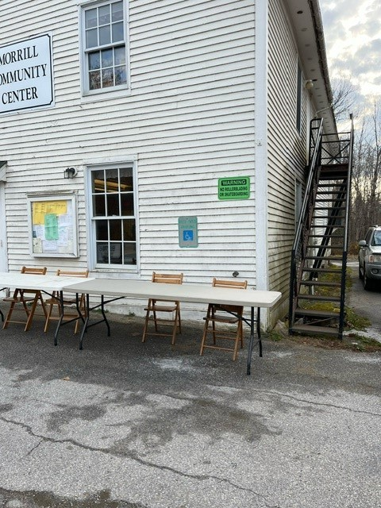

#1: Petition tables arranged on top of marked accessible parking spaces outside a polling place.

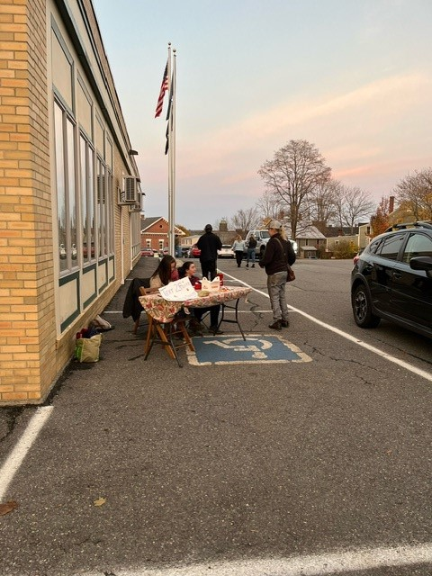

#2: A table setup in an accessible parking space, with two people seated at chairs.

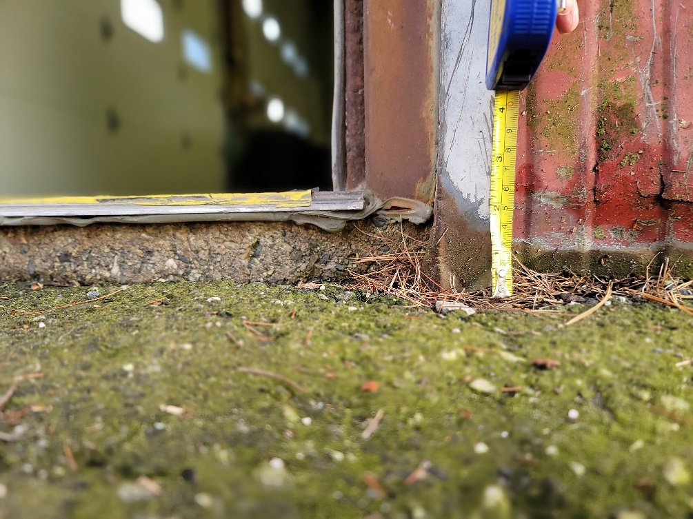

#3: A door threshold of two and a half inches at a marked accessible entrance.

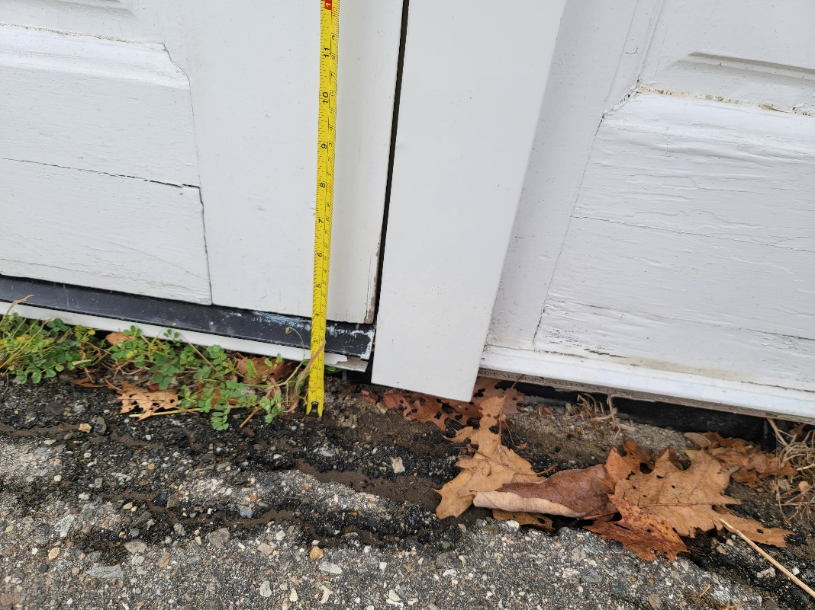

#3: A door threshold of three inches at a marked accessible entrance.

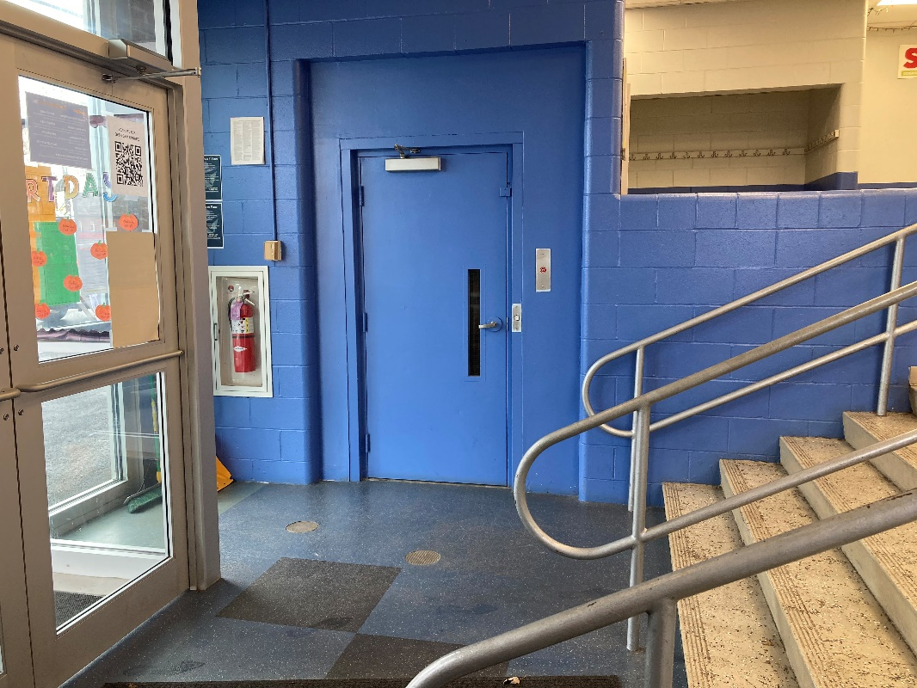

#4: An unmarked elevator at a polling place.

# 2024 VOTER EDUCATION: PROGRAM RECIPIENTS

* Affinity Maine
* Alpha One
* American Association of People with Disabilities
* Capitol Clubhouse
* Central Maine Community College
* Choices are for Everyone
* City of Portland, City Clerk’s Office
* City of Westbrook, City Clerk’s Office
* Community Living Association
* Consumer Council System of Maine
* Creative Trails
* Deering High School
* Democracy Maine
* Division of Health and Human Services (DHHS)
* Dorothea Dix Hospital
* Group Main Stream
* Looking Ahead Clubhouse
* Maine General
* Maine Health
* NeuroRestorative
* Noble High School
* Northern Aroostook Alternatives
* Northern Light Health
* Northern Maine Medical Center
* Office of Aging and Disability Services (OADS)
* Opportunity Enterprises
* Opportunity Trails
* Personal Services of Aroostook
* Pine Tree Society
* Riverview Hospital
* Speaking Up for Us
* Spurwink
* St. John Valley Associates
* St. Mary’s Regional Medical Center
* STRIVE
* The Progress Center
* Village Clubhouse
* Woodfords Family Services

# POLLING PLACE ACCESSIBILITY SURVEY

Information

1. Name
2. Name of polling place (Town, Building Name)

Parking Area

1. Are there designated accessible parking spaces?
2. Are the accessible parking spaces temporary or permanent?
3. How many permanent accessible parking spaces are there?
4. Do all permanent accessible parking spaces have a sign staked in the ground to mark each space? (The sign will most likely have a wheelchair symbol or say Handicapped Parking.)
5. Do all permanent accessible parking spaces have paint on the ground to mark the spaces?
6. Where are the accessible parking spaces?
7. Are the surfaces of the designated accessible parking spaces and access aisles stable, firm, and slip resistant? (§§502.4, 302.1)
8. Is there at least one designated van accessible space with signage AND a marked access aisle? (§§§208.2, 208.2.4, 502.6)

Exterior Route to Polling Place Entrance

1. Is the route at least 36" wide? (§403.5.1)
2. Is the route free of abrupt changes in level greater than 1/2", including stairs? (§303)
3. Are walking surfaces stable, firm, and slip resistant? (§302.1)
4. Does the route from accessible parking spaces to the accessible entrance cross curbs?
5. Are curb ramps provided? (§§§§303.4, 405.2, 405.5, 406.1)
6. Is the width of the curb ramp surface at least 36” (not counting the side flares)? (§405.5)

Maine Entrance of Polling Place

1. Is the main door into the facility the accessible entrance?
2. Do inaccessible entrances have signs directing you to the accessible entrance? (§216.6)
3. Is there a separate, accessible entrance?
4. For the alternate accessible entrance, is the door unlocked? (28 C.F.R. §§35.130, 35.133)

Ramp

1. Is there a ramp into the polling place?
2. Is the ramp permanent or temporary?
3. Is the ramp, measured between handrails, at least 36" wide? (§405.5)
4. Does the ramp have a level landing that is at least 60" long, at the top and bottom of each ramp section? (§405.7)

Push Button

1. Does the door have a push button?
2. Is the push button functioning? (When the push button is pressed, the door should open to a 90-degree angle and remain open for more than 5 seconds.) (§404.3.5)

Door

1. Is each door hardware usable with one hand without tight grasping, pinching, or twisting of the wrist? (§§309.4, 404.2.7)
2. Is the threshold at each door no higher than 1/2"? (Note: If the threshold is between 1/4" and 1/2" it must be beveled.) (§404.2.5)

Interior Route to Voting Area

1. Is the route at least 3 feet wide? (§403.5.1)
2. Is the route free of abrupt changes in level greater than ½”, including stairs? (§303)
3. Does the interior route to the voting area have stairs?
4. Accessibility option to get to second floor? (§402.2)

Voting Area

1. Are floor surfaces in the voting area stable, firm, and slip resistant? (§302.1)
2. Do the tables for voter check-in and voter registration appear to be between 28-inches to 36-inches tall? (§403.5.1)
3. Is there enough room to provide a route at least 36" wide to the registration table and voting stations? (§403.5.1)

Accessible Voting System

1. Is the Accessible Voting System set-up on a table in the voting area?
2. Is the machine functioning properly?
3. Is the privacy screen placed around the AVS?
4. Do you see yellow sign adhered to the privacy screen that says, "Accessible Voting Here"?
5. Is there a chair at the table for the Accessible Voting System?
6. Does the table for the AVS appear to be at an accessible height of 28-36 inches?
7. Are there headphones provided on the table?
8. Is the keypad on the table?

# POLLING PLACES VISITED

|  |
| --- |
| Abbot, Town Hall |
| Acton, Town Hall |
| Appleton, Fire Station |
| Arrowsic, Town Hall |
| Arundel, Municipal Building |
| Athens, Somerset Academy Building |
| Auburn, Auburn Hall Community Room |
| Auburn, Auburn Hall Council Chambers |
| Auburn, Senior Community Center |
| Auburn, Boys and Girls Club |
| Avon, Community Building |
| Baldwin, Community Center |
| Bangor, Cross Insurance Center |
| Bath, Middle School |
| Belfast, Methodist Church |
| Belfast, The Tarratine Tribe #13 |
| Belmont, Community Building |
| Berwick, Town Hall |
| Bethel, Mundt Allen Post #81 |
| Biddeford, High School |
| Bingham, Quimby Middle School |
| Boothbay Harbor, Municipal Building Fire Station |
| Boothbay, Town Office |
| Bowdoin, Central School |
| Bowdoinham, Community School |
| Bradley, Fire Station |
| Bremen, Town Center |
| Brewer, Joseph Ferris Recreational Building |
| Bridgewater, Civic Building |
| Bridgton, Town Hall |
| Bristol, Consolidated School |
| Brooks, Town Office |
| Brunswick, Coffin School and Junior High School |
| Bryant Pond, Woodstock Town Office |
| Bucksport, Jewett High School |
| Cambridge, Municipal Building |
| Camden, Public Safety Building |
| Canton, Town Office |
| Cape Elizabeth, High School |
| Caratunk, Town Hall |
| Caribou, Recreation Center |
| Carthage, Town Office |
| Casco, Crooked River Elementary School |
| Chelsea, Elementary School |
| Cherryfield, Town Office |
| Chesterville, Town Hall |
| Cornish, Pike Memorial Hall |
| Cumberland, Town Hall |
| Cushing, Community Center |
| Damariscotta, Town Hall |
| Dayton, Town Office |
| Dennysville and Edmunds Twp, Dennysville Town Office |
| Dixfield, Dirigo High School |
| Dresden, Pownalborough Hall |
| Durham, Community School |
| East Machias Town Office |
| Eastport, Shead High School |
| Eddington, Municipal Building |
| Edgecomb, Town Hall |
| Eliot, Marshwood Middle School |
| Ellsworth, City Hall Council Chambers |
| Ellsworth, City Hall Auditorium |
| Ellsworth, Maine Coast Baptist Church |
| Ellsworth, Your Place Community Center |
| Falmouth, High School |
| Farmington, Community Center |
| Fort Fairfield, Community Center |
| Fort Kent, Knights of Columbus |
| Franklin, Community Center |
| Freeport, High School |
| Friendship, Town Office |
| Gardiner, Boys and Girls Club |
| Georgetown, Community School |
| Gorham, Middle School |
| Gorham, Great Falls Elementary School |
| Gorham, Municipal Center/Shaw Gym |
| Gray, Newbegin Community Center |
| Greene, Fire Department |
| Greenville, Municipal Building |
| Guilford, Municipal Building |
| Hampden, Skehan Recreational Center |
| Hanover, Town Office |
| Harmony, Elementary School |
| Harpswell, Community School |
| Hartland, Irving Tanning Community Center |
| Holden, Municipal Building |
| Hollis, Community Building |
| Hope, Town Office |
| Houlton, Gentile Memorial Building |
| Industry, Town Hall |
| Jackman, Municipal Conference Room |
| Jay, Community Building |
| Kennebunk, Town Hall |
| Kennebunkport, Fire Department |
| Kingfield, Webster Hall |
| Kittery, Community Center |
| Leeds, Leeds Town Office |
| Lewiston, Green Ladle |
| Lewiston, Longley School |
| Lewiston, Memorial Armory |
| Lewiston, Montello School |
| Liberty, Town Office Building |
| Lisbon, High School |
| Litchfield, Sportsman’s Club |
| Lyman, Elementary School |
| Machias, Memorial High School |
| Madawaska, Town Office |
| Mars Hill, Community Center |
| Milford, Town Hall |
| Monson, Town Gym |
| Moose River, Town Hall |
| Morrill, Morrill Community Center |
| Moscow, Town Hall |
| Naples, Town Hall |
| New Gloucester, Fire and Rescue Building |
| New Sharon, Town Office |
| New Sweden, Town Office |
| New Vineyard, Community Room |
| Newcastle, Fire Station |
| Newry, Raymond C Foster Municipal Building |
| Nobleboro, Town Office |
| North Berwick, High School |
| North Yarmouth, Wescustogo Hall & Community Center |
| Ogunquit, Judson Dunaway Community Center |
| Old Orchard Beach, High School |
| Old Town, Elk's Lodge |
| Orland, Community Center |
| Orono, Collins Center |
| Owls Head, Community Building |
| Palermo, Town Office |
| Paris, Fire Department |
| Parkman, Town Office |
| Pembroke, Municipal Building |
| Peru, Town Office |
| Phillips, Town Office |
| Phippsburg, Town Hall |
| Pittsfield, Town Office |
| Pittston, Town Hall |
| Pittston, Town Office |
| Poland, Old Town Hall |
| Portland, Deering High School |
| Portland, East End Elementary School |
| Portland, Exposition Center |
| Portland, First Baptist Church |
| Portland, Grace Baptist Church |
| Portland, Italian Heritage Center |
| Portland, Merrill Rehearsal Hall |
| Portland, St. Pius Church |
| Portland, Woodfords Club |
| Pownal, Mallett Hall |
| Presque Isle, Sargent Community Center |
| Prospect, Fire Department |
| Randolph, Town Office |
| Raymond, Jordan Small Middle School |
| Richmond, Middle/High School |
| Rockland, Flanagan Community Center |
| Rockport, Rockport Public Library |
| Rockwood, Rockwood Community Center |
| Rumford, Mountain Valley High School Gym |
| Sabattus, Town Office |
| Saco, Thornton Academy |
| Sanford, Sanford High School |
| Scarborough, Scarborough High School |
| Searsmont, Searsmont Community Building |
| Searsport, Community Center |
| Sebago, Town Hall |
| Sidney, James H. Bean School |
| Skowhegan, Municipal Building |
| Solon, Municipal Office |
| South Berwick, Central School |
| South Bristol, Town Office |
| South Portland, American Legion Hall |
| South Portland, Boys & Girls Club |
| South Thomaston, Municipal Building |
| Southport, Town Hall |
| Standish, Municipal Center |
| Stockton Springs, Meeting Room |
| Strong, Forster Memorial Building |
| Temple, Town Hall |
| Tenants Harbor, Fire Station |
| The Forks, Town Hall |
| Thomaston, Municipal Building |
| Topsham, Mt. Ararat High School |
| Union, William Pullen Municipal Building |
| Van Buren, Community Center |
| Verona Island, Town Hall |
| Waldoboro, Municipal Building |
| Wales, Municipal Center |
| Warren, Masonic Hall |
| Washington, Gibbs Library |
| Weld, Town Office |
| Wells, Wells Jr. High School  West Bath, Fire Station |
| West Forks, Town Hall |
| West Gardiner, Fire Station |
| West Paris, Town Office |
| Westbrook, Community Center |
| Westport Island, Old Town Hall |
| Whitefield, Central Fire Station |
| Whiting, Community Building |
| Windham, High School |
| Windsor, School Gym |
| Wiscasset, Community Center  Wilton, Meeting Room |
| Woolwich, Central School |
| Yarmouth, High School |
| York, Senior High School |

1. <https://www.newscentermaine.com/article/news/politics/elections/voting-rights-lawsuit-filed-against-maine-sec-of-state/97-391f686e-71c9-4955-a556-4eca53a23a23>
2. <https://drme.org/wp-content/uploads/2024/06/DRM-DE-IDENTIFIED-ELECTION-REPORT-11.7.23.pdf>