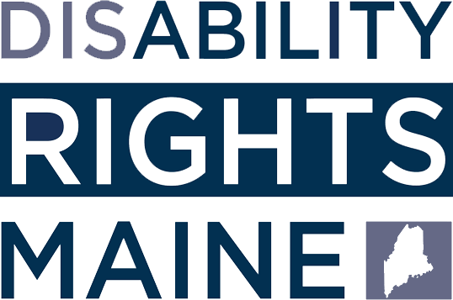
Amoko Y’ubufasha
VUGANA NA DRM

160 Capitol Street, Suite 4
Augusta, ME 04330
800.452.1948 (V/TTY)
207.626.2774 (V/TTY)
207.766.7111 (VP)
207.621.1419 (FAX)
advocate@drme.org
deafservices@drme.org
- Amakuru no guhuza abantu na serivisi
- Ubuvugizi bw’umuntu ku giti cye
- Uguhagararirwa mu mategeko
- Uburezi n’amahugurwa
- Ubufasha no kwivugira

Ubuvugizi Rusange
DRM kandi ishyira imbaraga nyinshi mu buvugizi rusange bukubiyemo:
- Kugira uruhare mu matsinda y’abafatanyabikorwa;
- Kugera ku bantu aho bari mu miryango;
- Gushakisha amakuru no kugenzura porogaramu zifasha;
- Kuvugurura politiki rusange.

Ukiyishak, iyi boroshire iri muri mu buryo butandukanye.
Ubugeni bw’urupapuro rubanza bwakozwe na Amy Fecteau.





Disability Rights Maine ifashwa na: grants from the Administration on Disabilities, the Center for Mental
Health Services, the Rehabilitation Services Administration, the Social Security Administration, the U.S. Department of Justice Office on Violence Against Women, the State of
Maine, the MCLSFC, the Maine Health Access Foundation, ndetse n’inkunga z’abikorera cyangwa abantu ku giti cyabo.
Disability Rights Maine ni a 501(c)(3) corporation.
Inkunga ntizisoreshwa kandi turazishimira byimazeyo.

Kugera ku bintu.
Kureshya.
Kwibeshaho.

www.drme.org

Ubutumwa Bwacu
Disability Rights Maine (DRM) ni ikigo cya Maine gishinzwe kurinda no kuvugira , gitumwe kandi guteza imbere ubutabera, kureshya hashyrwa mu bikorwa uburenganzira ndetse no gukuza amahirwe ku bantu bafite ubumuga muri Maine.

Indangagaciro zacu
DRM yemera ko imiryango y’uburenganzira bw’abantu bafite ubumuga are indatandukanywa n’imiryango Y’uburenganzira bw’abantu muri rusange hashingiwe ku moko y’abantu, ubukungu ndetse no kuringanira k’ibitsina byombi. Twavuguruye imishinga yacu kugirango turandure ibijyanye no kutareshya kw’amoko, ukutangana gushingiye ku bushobozi, ukutangana gushingiye ku bitsina ndetse no guhorwa ibitekerezo, hamwe no guca ibijyanye no kubura amahirwe mu nzego z’imitegekere.

Ikerekezo cyacu
Abantu bafite ubumuga ntibagomba guhabwa akato, guteshwa agaciro no guhezwa. Disability Rights Maine ishishikajwe no kubona isi y’ukuri, itagira imbogamizi aho abantu bafite ubumuga bafite imbaraga n’ubwigenge. Muri iyi si, abafite ubumuga bafite ubushobozi bwose bwo kugera ku burezi, imirimo, ibibagirira akamaro, ndetse n’umuryango.

DRM ntijya iheza abantu hashingiwe kugitsina, ub- woko, ibara, inkomoko, idini, ubumuga, imyaka,
cyangwa amahitamo y’imikoreshereze y’igitsina muri gahunda zayo cyangwa mu bikorwa byayo.

Ninde DRM ivugira?
DRM ihagarariye abantu bakurikira :
- Abujuje ibyo zimwe muri porogaramu zacu zisaba;
- Abafite ikibazo gihura na bimwe mu byihutirwa muri porogaramu zacu;
- Abashaka ubufasha bw’ikibazo kijyanyen’ubumuga bwabo;
- Abafite ikibazo kijyanye cyangwa cyakemuka mu nzira y’amategeko.
DRM kandi ikemura ibibazo hashingiwe ku kuba hari uburyo bwo kubikemura.
Ukeneye ayandi makuru ku bijyanye N’ubufasha na gahunda z’abantu zihutirwa, Sura urubuga rwacu rwa Interineti cyangwa uhamagare ku biro byacu .

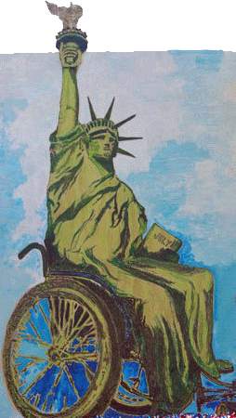

Ese ni iki DRM yamfasha ?
Ibyo DRM ifasha bikubiyemo:
- Kuregera ikoreshwa nabi,
kwirengagiza no huhonyora uburenganzira bw’ibanze;
- Kugera kuri serivisi z’ubuvuzi ndetse n’iz’ubuzima bwo mu mutwe mu muryango;
- Kuvugira abantu ngo bibesheho, mu muryango bihitiyemo;
- Guhohoterwa mu kubona aho
gutura, ubufasha rusange bw’ibanze ndetse no muri serivisi za leta;
- Uguhagararirwa no gufashwa mu gufata ibyemezo;
- Umurimo n’ibijyanye no gusubizwa mu kazi;
- Kugera ku ikoranabuhanga ridaheza;
- Kuvugira abantu bafite ubumuga bwo kutumva no gutumanaho;
- Kubasha gukora amatora;
- Kugera kuri serivisi zo gusubizwa mu buzima busanzwe n’izijyanye no
kwibeshaho ntawe uteze amaboko.

